The Correspondence Chess League of America
1154 Dayton Drive, Galesburg IL 61401-1313

Opening __________________Opponent’s Rating ________
Event _____________________________ Section ________
Date Started _____________ Date Reported _____________
White __________________ Black ____________________
Address __________________________________________
_________________________________________________
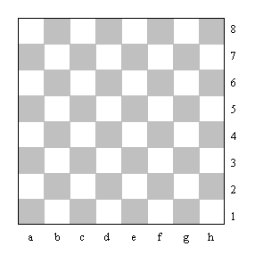

Print in the location of pieces with soft pencil; use a red pencil for the white pieces and a black pencil for the black pieces. Print capital letters.

Erase and change position of piece when it is moved. Set up board to decide moves.

Record the date you receive and send each move in the righthand columns. Write R for received, and S for sent, at the head of the columns.
Rec.  on | Sent  on | Time  used | Total  Time | White | No | Black | Rec.  on | Sent  on | Time  used | Total  Time
 |  |  |  |  | 1
 |  |  |  |  | 2
 |  |  |  |  | 3
 |  |  |  |  | 4
 |  |  |  |  | 5
 |  |  |  |  | 6
 |  |  |  |  | 7
 |  |  |  |  | 8
 |  |  |  |  | 9
 |  |  |  |  | 10

Rec.  on | Sent  on | Time  used | Total  Time | White | No | Black | Rec.  on | Sent  on | Time  used | Total  Time
 |  |  |  |  | 11
 |  |  |  |  | 12
 |  |  |  |  | 13
 |  |  |  |  | 14
 |  |  |  |  | 15
 |  |  |  |  | 16
 |  |  |  |  | 17
 |  |  |  |  | 18
 |  |  |  |  | 19
 |  |  |  |  | 20
 |  |  |  |  | 21
 |  |  |  |  | 22
 |  |  |  |  | 23
 |  |  |  |  | 24
 |  |  |  |  | 25
 |  |  |  |  | 26
 |  |  |  |  | 27
 |  |  |  |  | 28
 |  |  |  |  | 29
 |  |  |  |  | 30
 |  |  |  |  | 31
 |  |  |  |  | 32
 |  |  |  |  | 33
 |  |  |  |  | 34
 |  |  |  |  | 35
 |  |  |  |  | 36
 |  |  |  |  | 37
 |  |  |  |  | 38
 |  |  |  |  | 39
 |  |  |  |  | 40
 |  |  |  |  | 41
 |  |  |  |  | 42
 |  |  |  |  | 43
 |  |  |  |  | 44
 |  |  |  |  | 45
 |  |  |  |  | 46
 |  |  |  |  | 47
 |  |  |  |  | 48
 |  |  |  |  | 49
 |  |  |  |  | 50

